Step: 1 We have to make an EC2 instance.

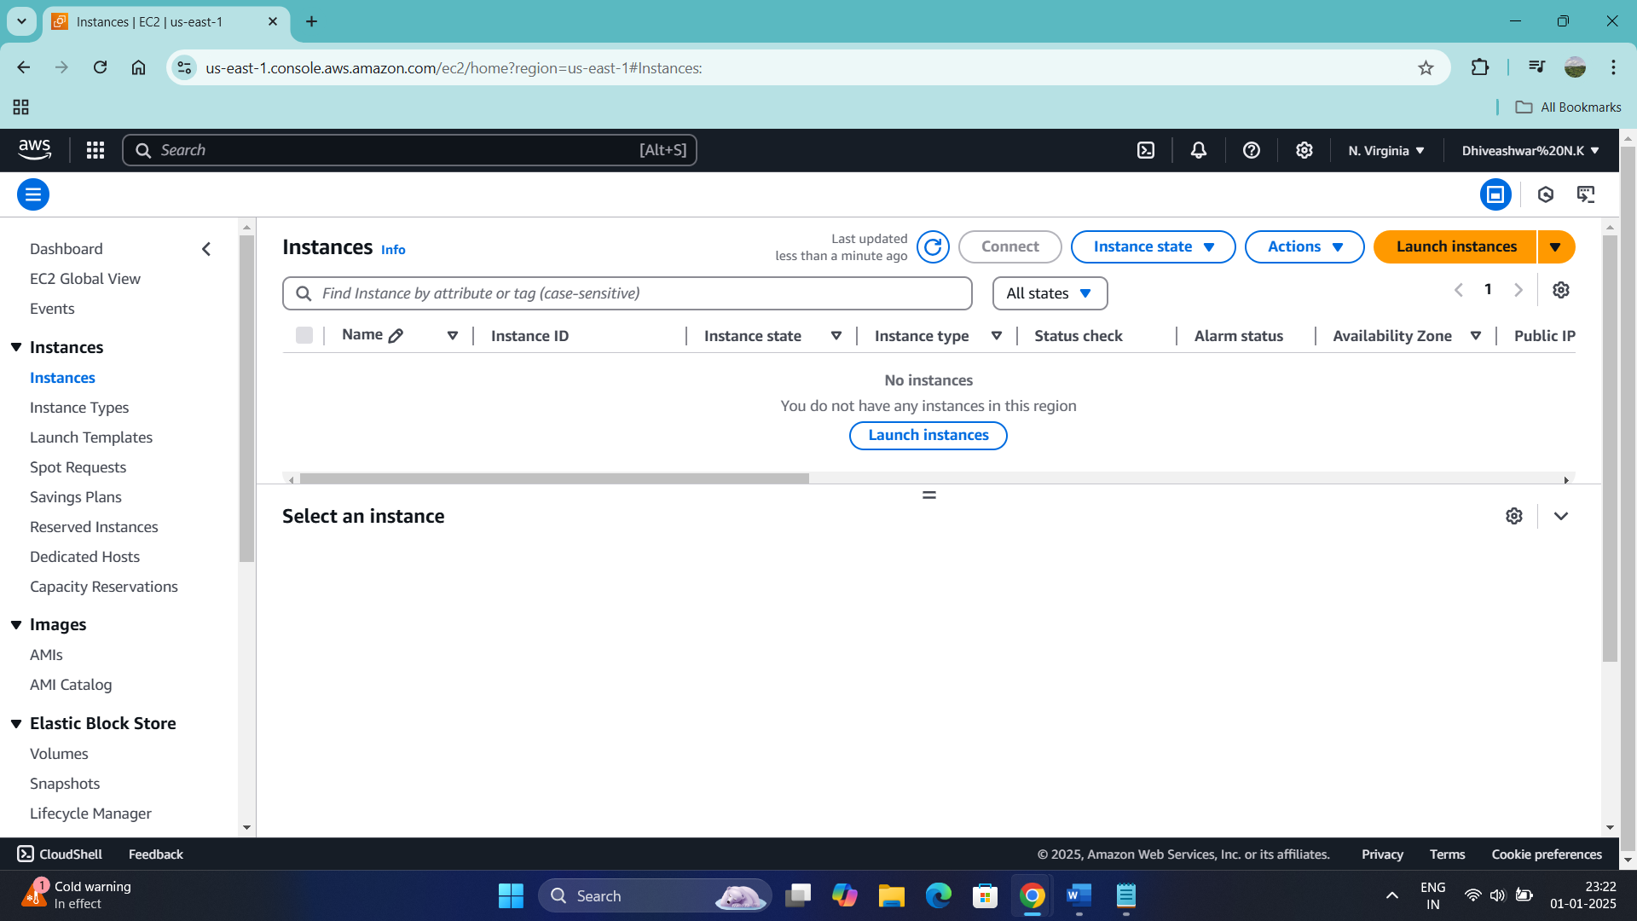

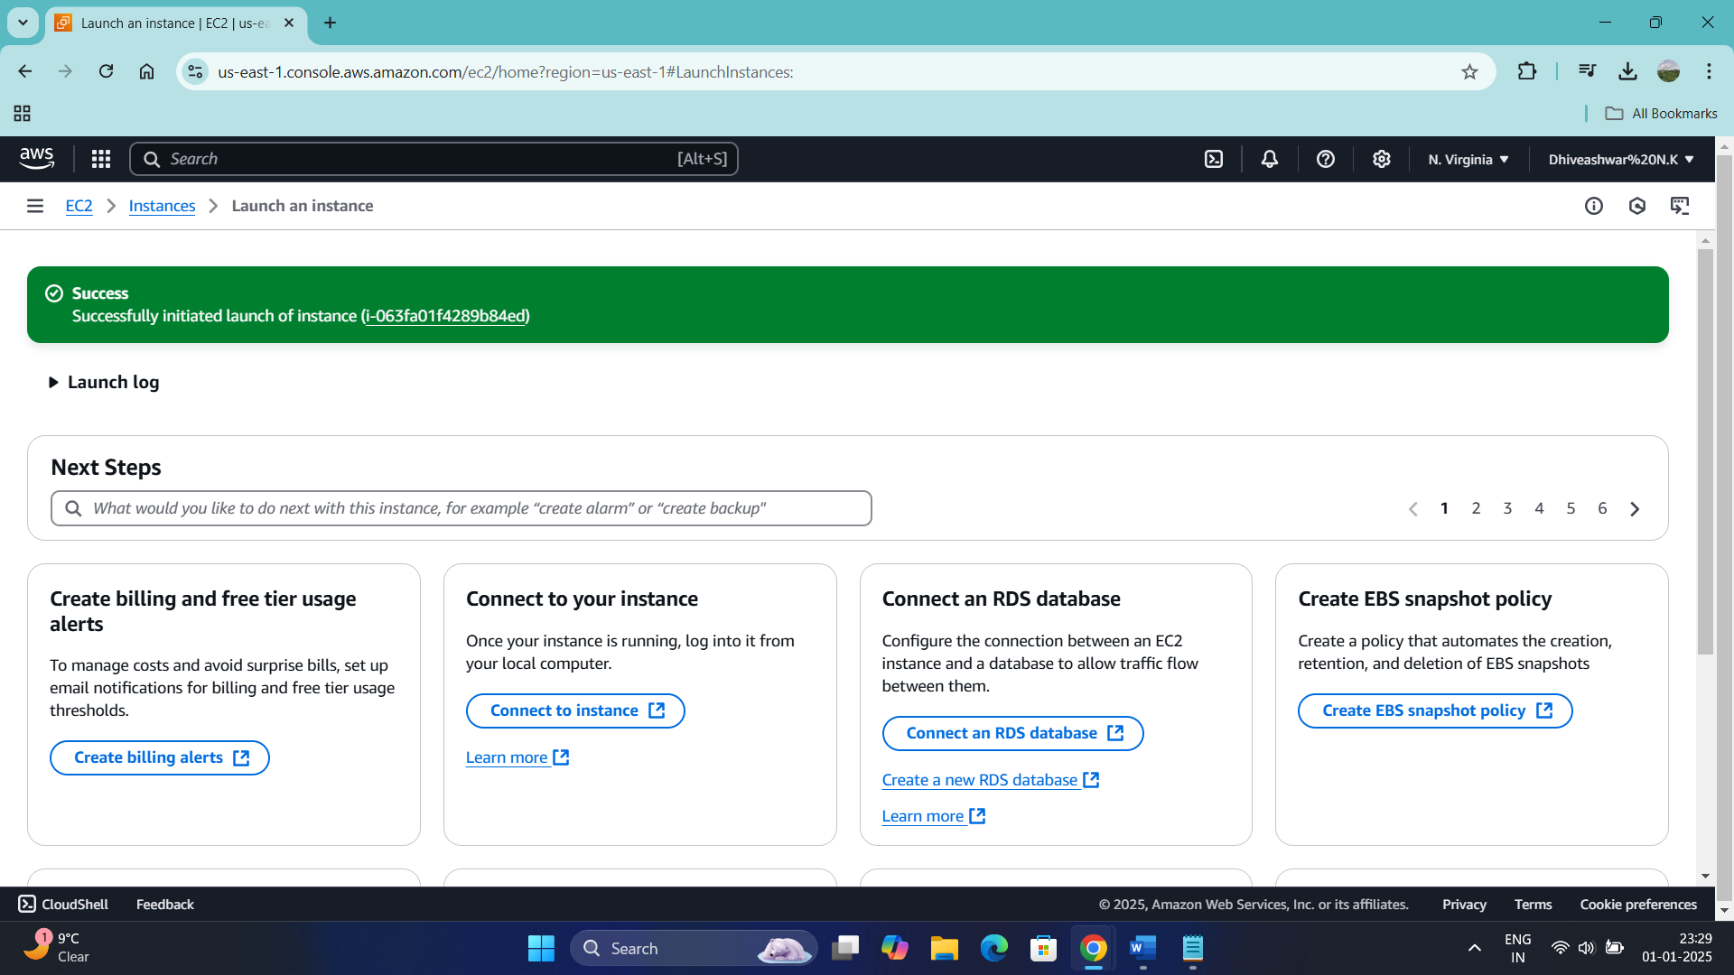

Step 2: connect the ec2 instance

Step 3: Installing Jenkins

Commands used:

Step 4: Jenkins has installed

Step 5: Editing the inbound rules and saving for the access of Jenkins

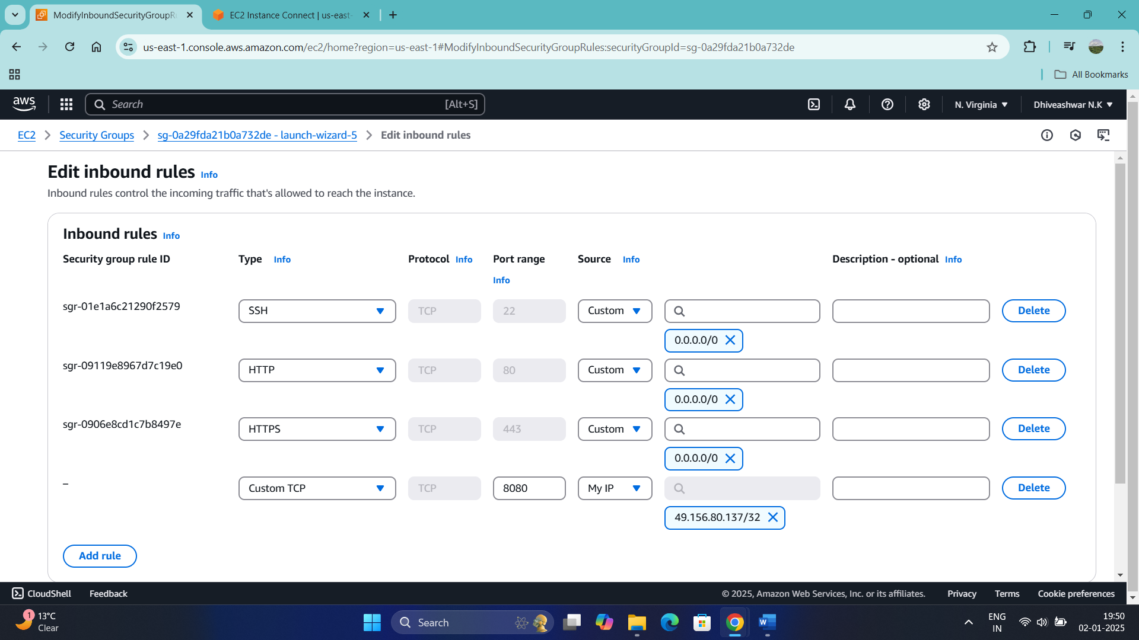

Step : 6 Accessing the Jenkins by using the command sudo cat

Step : 7 Creating the admin user

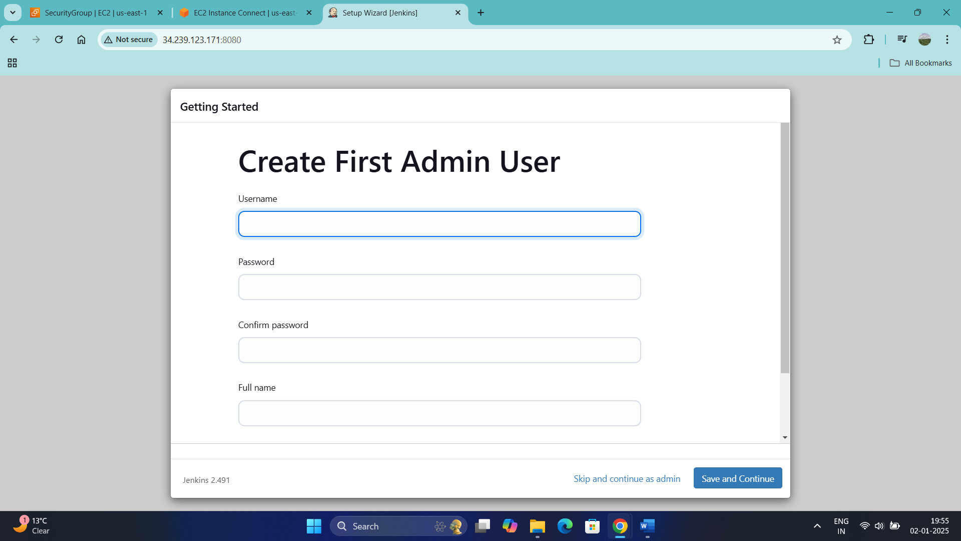

Step: 8

Step : 9

Step : 10

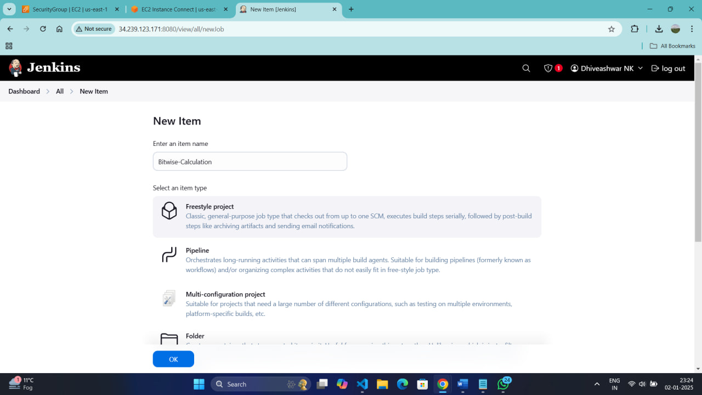

Step: 11 Creating an SSH key

Step : 12 Knowing the public and private keys:

Step : 13 Adding new ssh key in Git Hub

Step : 14 Verification process

Step : 15 After verification we can notice that Authentication keys are being added

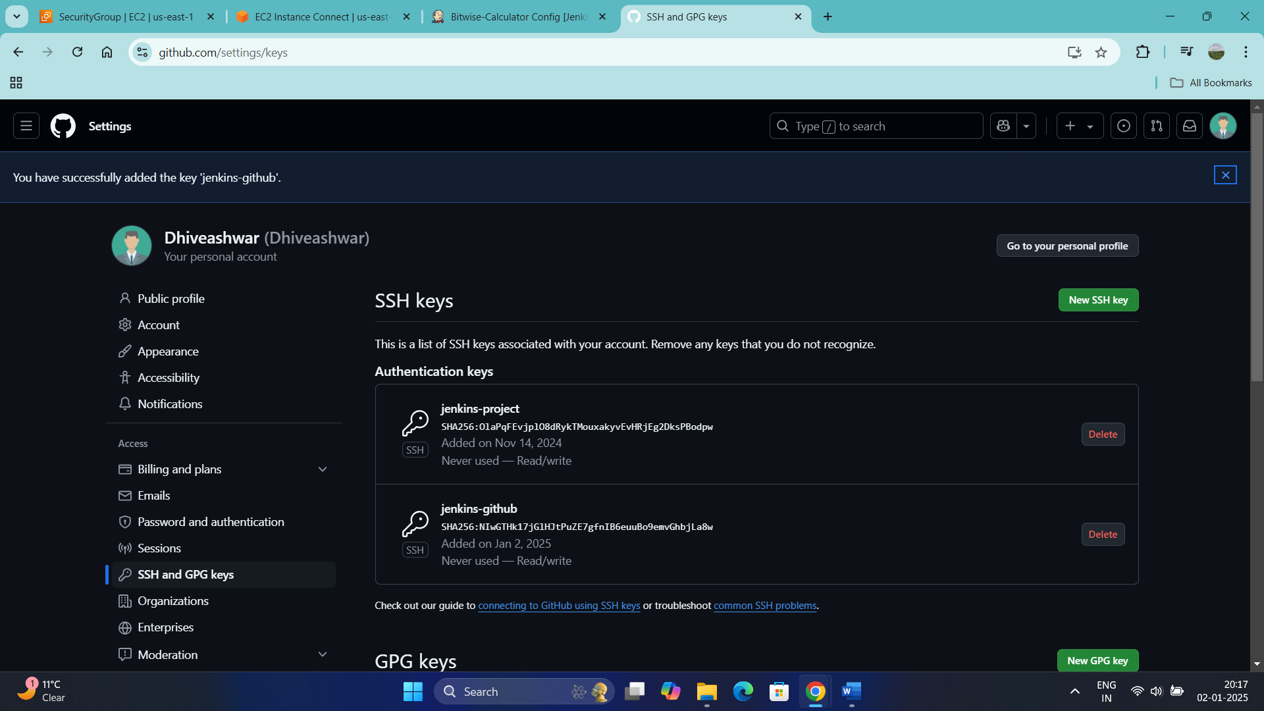

Step : 16 Now giving the Jenkins credentials and saving

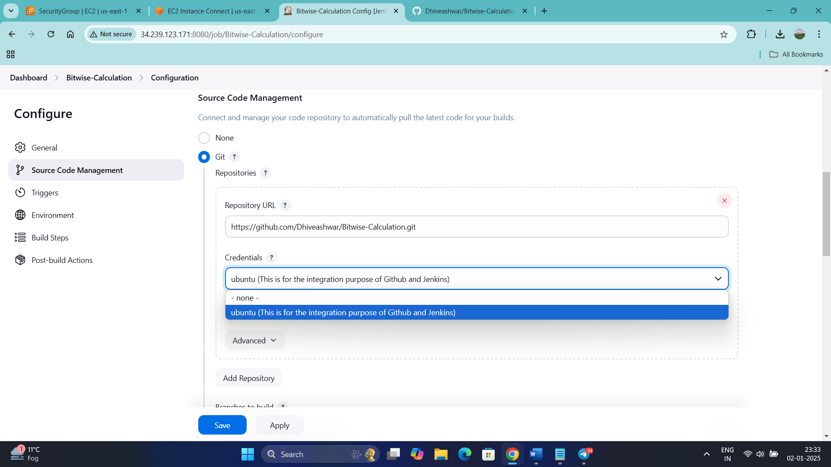

Step : 17 Building in Jenkins

Step: 18 Now checking once that the code has been came

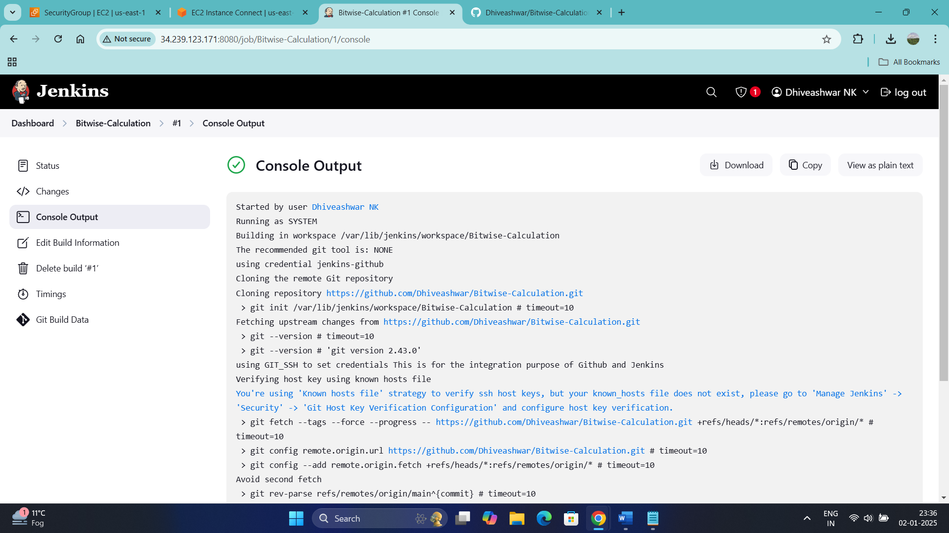

Step:19 Running and seeing in the port 8000 and the commands used to run in the port 8000 are:

source ~/venvs/bitwise-env/bin/activate

pip install uvicorn

uvicorn main:apphost 0.0.0.0 --port 8000

python3 -m http.server 8000 --bind 0.0.0.0

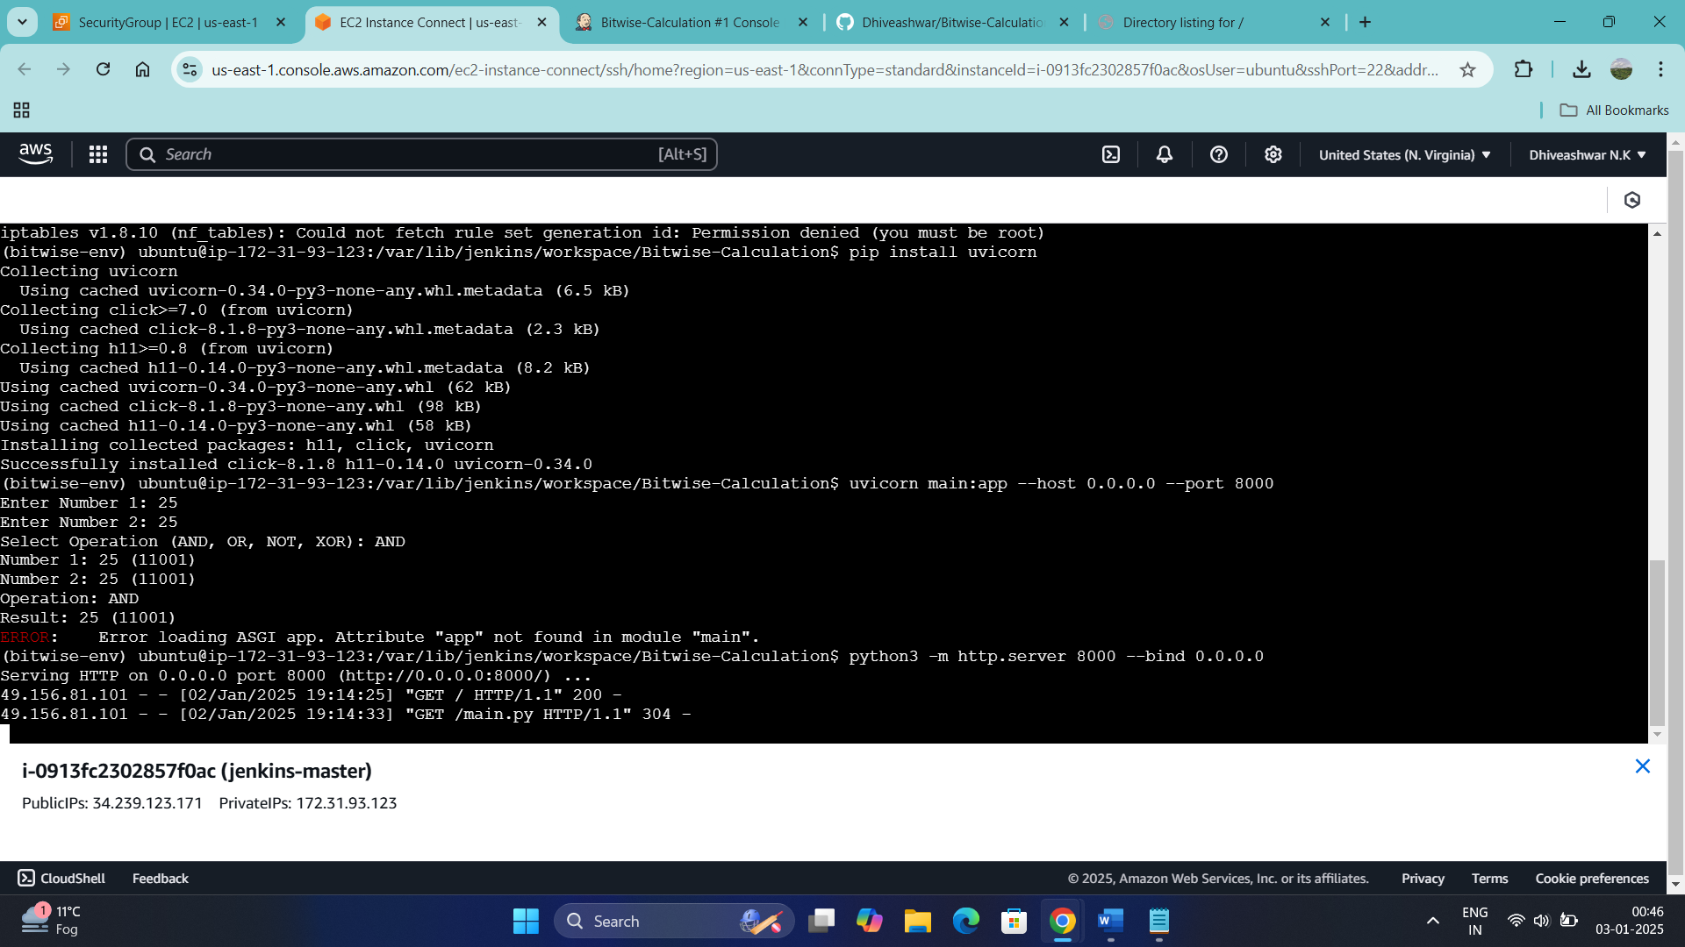

Step 20: Installing Docker

Step : 21 Creating an docker file and the command is Vim dockerfile and entering the following instructions:

FROM node: 12.2.0-alpine

WORKDIR app

COPY RUN npm install

EXPOSE 8000

CMD "source ~/venvs/bitwise-env/bin/activate", "python3 -m http.server 8000 --bind 0.0.0.0"

Step: 22

Thank you.